PROJECT REPORT (CSN304)
A report submitted in partial fulfilment of the requirement for the course

ARTIFICIAL INTELLIGENCE
Part of the degree of
BACHELOR OF COMPUTER SCIENCE AND ENGINEERING



Submitted to
Dr. Himani Sharma
Assistant Professor

Submitted by:

PRANJAL JOSHI | (1000026394)
MD ARKAM RAZA | (1000026421)
SUMIT SINGH BISHT | (1000026455)
DISHITA TYAGI | (1000026554)

Section -I

SCHOOL OF COMPUTING DIT UNIVERSITY, DEHRADUN
Uttarakhand, India October 2026

TABLE OF CONTENTS

Project Metadata & Team Information Project Brief (P-2)
- Abstract
- Introduction & Problem Statement
- Scope and Constraint
- AI Foundations & Agent Architecture (PEAS Model)
- System Architecture & Module Decomposition
- State abd Action Moduling
- Formal AI Problem Formulation
- Search Algorithms
- Implementation details
- Conclusion
- References & Bibliography
- System Flowchart

Project Metadata & Team Information
Field | Details
Project Title | Automated Room Allocation System
Project ID | P-2
Core AI Concepts | Intelligent problem-solving, Constraint Satisfaction Problems (CSP), Backtracking, Constraint Propagation, domain reduction, and constraint validation.
Primary Language | Python 3
Core Dependencies | Python standard library, including Tkinter, time, and other built-in modules used in the application.
Graphical User Interface | Python Tkinter GUI.
Allocation Technique | Constraint Satisfaction Problem (CSP)

Project Brief (P-2)
Objective: Develop an intelligent system that automatically assigns students to examination rooms and seats while satisfying predefined constraints such as room capacity, accessibility requirements, and group separation.
Tasks:
- Represent students, rooms, and seats using suitable data structures.
- Define students and their seating positions as variables and possible seats as domains.
- Implement a Constraint Satisfaction Problem (CSP) to generate valid seating arrangements.
- Apply the Backtracking algorithm to search for suitable seat assignments.
- Implement Constraint Propagation to reduce possible seating choices and improve allocation efficiency.
- Define constraints such as room capacity, unique seat allocation, accessibility, and group separation.
- Give priority to students with accessibility requirements when assigning seats.
- Detect allocation conflicts and validate the final seating arrangement.
- Develop a Python-based graphical user interface using Tkinter.
- Display the seating chart, allocation analytics, and conflict reports.

Abstract

The Automated Room Allocation System is a Python-based application designed to automate the process of assigning students to examination rooms and seats. The system uses Artificial Intelligence concepts, particularly Constraint Satisfaction Problems (CSP), Backtracking, and Constraint Propagation, to generate valid and efficient seating arrangements.
The main objective of this project is to reduce the time and effort required for manual room allocation while minimizing errors and ensuring proper seat distribution. It considers various constraints, including room capacity, unique seat assignment, accessibility requirements, and separation of students belonging to the same group. Priority is given to students with accessibility requirements to ensure suitable seating arrangements.
The application is developed using Python 3 and the Tkinter graphical user interface. It provides features such as automatic seat allocation, animated allocation, seating chart visualization, allocation analytics, conflict detection, undo, and unassign options. It also identifies situations where a valid seating arrangement cannot be generated due to conflicting constraints.
Overall, the Automated Room Allocation System provides a user-friendly and efficient solution for examination seating management. It demonstrates the practical application of AI-based problem-solving techniques and helps make the allocation process more organized, accurate, and reliable.

Introduction & Problem Statement

Background & Motivation
Room allocation is an important task in educational institutions, especially during examinations when a large number of students must be assigned to different rooms and seats. Traditionally, this process is performed manually, which can be time-consuming, complicated, and prone to errors. Manual allocation may also create problems such as exceeding room capacity, duplicate seat assignments, improper seating arrangements, and difficulties in providing accessible seats to students with special requirements.
The Automated Room Allocation System is developed to overcome these challenges by using Artificial Intelligence techniques. It applies Constraint Satisfaction Problems (CSP), Backtracking, and Constraint Propagation to generate suitable seating arrangements while satisfying predefined conditions.
The main motivation behind this project is to make the examination seating process faster, more accurate, organized, and user-friendly. It also aims to reduce administrative workload, ensure proper utilization of available rooms, and provide priority seating for students with accessibility requirements.
Through a graphical interface developed using Python Tkinter, the system makes room allocation easier to manage and allows users to view seating charts, monitor allocation progress, and identify conflicts.

Problem Formulation
The Automated Room Allocation System is formulated as a Constraint Satisfaction Problem (CSP) in which students must be assigned to available seats in different examination rooms while satisfying a set of predefined constraints.
The main problem is to generate a valid seating arrangement that ensures proper room utilization, avoids duplicate seat assignments, and considers students' accessibility requirements and group separation.

1. Problem Components
- Variables: Each student who needs to be assigned a seat.
- Domains: All available seats in the examination rooms.
- Constraints: Rules that must be followed during the allocation process.
- Initial State: Student details, room information, and available seating positions.
- Goal State: A complete and valid seating arrangement for all students.

2. Constraints
- Room Capacity: The number of students assigned must not exceed the available seats.
- Unique Seat Assignment: Each seat can be assigned to only one student.
- Accessibility: Students with accessibility requirements must receive suitable seats.
- Group Separation: Students belonging to the same group should not sit side by side.
- Valid Allocation: All assigned seats must satisfy the defined constraints.

3. Problem-Solving Approach
The system uses the following AI techniques:
- Constraint Satisfaction Problem (CSP): Models the allocation problem using variables, domains, and constraints.
- Backtracking Algorithm: Searches for valid seat assignments and returns to previous choices when a conflict occurs.
- Constraint Propagation: Reduces possible seat choices by applying constraints during the allocation process.
- Validation: Checks whether the final seating arrangement satisfies all the required conditions.

4. Goal
The goal is to develop an efficient and reliable system that automatically assigns students to suitable examination seats, minimizes allocation conflicts, and reduces the effort involved in manual room allocation.

Project Objectives
The main objective of the Automated Room Allocation System is to develop an intelligent and efficient application that automatically assigns students to examination rooms and seats while satisfying predefined constraints.

Specific Objectives
1. Automate Seat Allocation: Automatically assign students to available seats in different examination rooms.
2. Optimize Room Utilization: Ensure proper utilization of available rooms without exceeding their seating capacity.
3. Apply AI Techniques: Use Constraint Satisfaction Problems (CSP), Backtracking, and Constraint Propagation to generate valid seating arrangements.
4. Avoid Allocation Conflicts: Ensure that each student receives a unique seat and prevent duplicate assignments.
5. Provide Accessibility: Give priority to students with accessibility requirements by assigning them suitable seats.
6. Maintain Group Separation: Prevent students belonging to the same group from sitting side by side.
7. Detect Conflicts: Identify and report situations where the allocation constraints cannot be satisfied.

Scope and Constraints

1. Scope of the Project
The Automated Room Allocation System focuses on automating the process of assigning students to examination rooms and seats using Artificial Intelligence techniques.
The scope of this project includes:
- Student Management: Maintain student details such as ID, name, group, and accessibility requirements.
- Room Management: Define examination rooms, their dimensions, seating capacity, and accessibility facilities.
- Automatic Seat Allocation: Assign students to available seats based on predefined rules.
- AI-Based Problem Solving: Apply CSP, Backtracking, and Constraint Propagation to generate valid seating arrangements.
- Accessibility Support: Provide suitable seating arrangements for students with special accessibility requirements.
- Group Separation: Maintain separation between students belonging to the same group.
- Graphical Representation: Display seating arrangements through a visual seating chart.
- Conflict Detection: Identify allocation problems and display conflict reports.
- Additional Features: Provide animation, undo, unassign, and clear-all options.

2. Constraints of the Project
The system operates under certain limitations and predefined conditions:
- Room Capacity: Students cannot be assigned beyond the available seating capacity.
- Unique Seating: A single seat cannot be assigned to multiple students.
- Accessibility Requirements: Students requiring accessible seating must be assigned suitable positions.
- Group Separation: Students from the same group should not sit side by side.
- Limited Resources: Allocation depends on the number of available rooms and seats.
- Conflicting Conditions: A valid arrangement may not be possible when the available seats cannot satisfy all constraints.
- Data Storage: Student and room information is maintained using Python data structures rather than an external database.
- Platform Dependency: The application requires a compatible Python environment to run.

AI Foundations & Agent Architecture (PEAS Model)

Intelligent Agent Characterization
The Automated Room Allocation System can be characterized as an intelligent problem-solving
agent that assigns students to examination seats while satisfying predefined constraints. It uses Artificial Intelligence techniques such as Constraint Satisfaction Problems (CSP), Backtracking, and Constraint Propagation to find valid seating arrangements.

The PEAS Framework
Component | Specification
Performance Measure | Valid seat allocation, no duplicate assignments, proper room utilization, accessibility, and minimum conflicts
Environment | Students, examination rooms, available seats, and allocation constraints.
Actuators | Assign seats, update seating charts, perform undo or unassign operations, and display reports.
Sensors | Student details, room capacity, seat availability, group information, and accessibility requirements.

Agent Classification: Goal-Based and Utility-Based Operations
The Automated Room Allocation System follows a goal-based problem-solving approach and includes utility-related considerations to generate suitable seating arrangements. It uses Artificial Intelligence techniques such as Constraint Satisfaction Problems (CSP), Backtracking, and Constraint Propagation to achieve its allocation goals.

1. Goal-Based Operations
A goal-based agent takes decisions to achieve a specific objective. In this project, the main goal is to allocate all students to suitable examination seats while satisfying the predefined constraints.
- Assign every student an available seat.
- Ensure that room capacity is not exceeded.
- Avoid duplicate seat assignments.
- Provide suitable seating for students with accessibility requirements.
- Maintain separation between students belonging to the same group.
- Generate a valid seating arrangement with minimum conflicts.

2. Utility-Based Operations
A utility-based agent evaluates different possible outcomes and prefers the most suitable one according to certain criteria.
In this project, utility-related considerations include:
- Room Utilization: Make effective use of available seating capacity.
- Accessibility Priority: Give priority to students who require accessible seating.
- Conflict Reduction: Avoid invalid or conflicting seat assignments.
- Allocation Efficiency: Reduce unnecessary searching through Backtracking and Constraint Propagation.
- Suitable Seating: Select seats that satisfy the maximum number of predefined requirements.

3. Operational Process
- Receive student and room information.
- Identify available seats and allocation constraints.
- Select a student for allocation.
- Evaluate suitable seating positions.
- Assign a seat if all required constraints are satisfied.
- Apply Backtracking if a conflict occurs.
- Validate the final seating arrangement.
- Display the seating chart and allocation report.

Environment Classification
Dimension | Classification | Justification
Observability | Fully Observable | The system receives student details, room information, seat availability, and predefined constraints as input.
Determinism | Deterministic | Given the same input data and allocation rules, the system follows predictable allocation operations.
Temporality | Sequential | Each seat assignment affects the available seats and choices for the remaining students.
Dynamics | Static | Student and room information remains unchanged during a particular allocation process unless the user modifies it.
Discreteness | Discrete | Students, rooms, seats, and allocation decisions are represented as separate, countable elements.
Agency | Goal-Based | The system works towards the goal of generating a valid seating arrangement while satisfying all predefined constraints.

Agent Decision Flow
Stage | Component | Description
1. Environment | Students, examination rooms, available seats, and allocation rules | Provides the environment from which the agent receives information.
2. Perception | Student details, room capacity, group information, and accessibility requirements | Collects the information required for planning.
3. State Estimation | Student list, room details, seat availability, and constraints | Builds an internal representation of students, rooms, and available seating positions.
4. Decision Engine | CSP and constraint evaluation | Evaluates possible seat assignments and selects suitable allocation choices.
5. Pathfinding | Backtracking and Constraint Propagation | Searches for valid seating arrangements, reduces possible choices, and handles conflicts by trying alternative assignments.
6. Output / Replanning | Seating chart, analytics, and conflict reports | Displays the final seating arrangement, validates constraints, and reports conflicts if a valid allocation cannot be found.

System Architecture & Module Decomposition

High-Level Architecture

The Automated Room Allocation System follows a modular architecture that separates student data management, room and seat management, AI-based allocation logic, constraint validation, and graphical user interface.
The system is developed using Python 3 and Tkinter. Its core allocation process uses Constraint Satisfaction Problems (CSP), Backtracking, and Constraint Propagation to generate valid seating arrangements. The modular design makes the system easier to understand, maintain, and improve.

Layer / Module | Files | Responsibility
Student Data Management | Python Lists and Dictionaries | Stores student details such as ID, name, group, and accessibility requirements.
AI State Model | CSP Variables, Domains, and Constraints | Represents students as variables, available seats as domains, and allocation rules as constraints.
Constraint Management | Constraint-checking functions | Checks room capacity, unique seat assignment, accessibility, and group separation.
Search Engine | solve() | Implements the Backtracking-based search process to find valid seat assignments.
Validation Module | validate() | Checks whether the generated seating arrangement satisfies the required constraints
Reporting Module | success_report(), explain() | Generates allocation results and explains conflicts or unsuccessful allocation attempts.
Graphical User Interface | Python Tkinter | Provides the main application window and user interaction features.

Graph Representation
The Automated Room Allocation System can be represented conceptually as a Student–Seat Assignment Graph, where students are connected to the seats they can potentially occupy. The allocation process selects suitable student-seat assignments while satisfying the predefined constraints.

1. Graph Components
- Student Nodes: Represent individual students who need seat allocation.
- Seat Nodes: Represent available seats in different examination rooms.
- Assignment Edges: Represent possible assignments between students and seats.
- Conflict Relationships: Represent restrictions between students, such as students from the same group not sitting side by side.

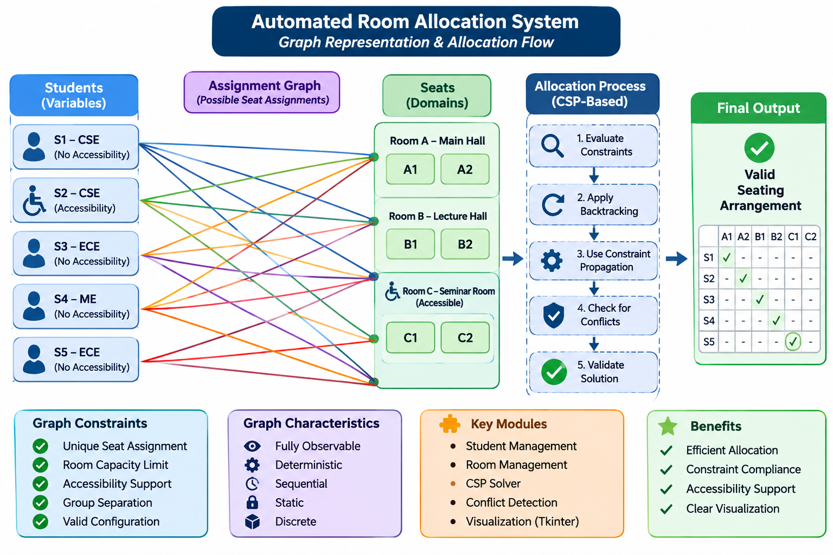

State and Action Modeling
The Automated Room Allocation System represents the allocation problem using students, available seats, and predefined constraints. Each student is treated as a variable, while the available seats form the possible values (domains) for that variable.
An allocation action represents assigning a particular student to an available seat. The system checks whether the assignment satisfies all constraints before accepting it.
State Representation:
- Student ID: Unique identification of each student.
- Student Group: Branch or group to which the student belongs.
- Accessibility Requirement: Indicates whether the student requires special seating.
- Room Information: Room name, dimensions, and accessibility facilities.
- Seat Information: Room name, row, and column of each seat.
- Assignment State: Records which student is assigned to which seat.
Action Representation:
- Assign a student to a suitable seat.
- Check the validity of the assignment.
- Reject an assignment if it violates a constraint.
- Backtrack and try another available seat when a conflict occurs.

4. Constraint and Search Modules
The system uses a Constraint Satisfaction Problem (CSP) model to generate valid seating arrangements. The search process evaluates available seats and applies predefined constraints before making an assignment.
The Backtracking algorithm explores possible seat assignments and returns to previous choices whenever a conflict occurs. Constraint Propagation helps reduce unsuitable seating choices during the allocation process.
Component | Responsibility
CSP Model | Defines variables, domains, and constraints.
Backtracking | Searches for valid student-seat assignments.
Constraint Propagation | Reduces possible seating choices.
solve() | Performs the main allocation search.
settle() | Supports the constraint propagation process.
find_conflicts() | Identifies allocation conflicts.
validate() | Checks the validity of the final arrangement.
success_report() | Generates the successful allocation report.
explain() | Explains allocation failures and possible causes.

5. Constraint Validation and Conflict Management
The system checks different conditions to ensure that the generated seating arrangement is valid. If an assignment violates a constraint, the search process attempts another suitable assignment through Backtracking.
The main constraints include:
- Room Capacity: Prevents assigning more students than the available seats.
- Unique Seat Assignment: Ensures that each seat is occupied by only one student.
- Accessibility Requirements: Ensures that students with accessibility requirements receive suitable seating.
- Group Separation: Prevents students belonging to the same group from sitting side by side.
- Priority Management: Gives priority to students with accessibility requirements during allocation.
The conflict management module identifies situations where the allocation is unsuccessful and provides explanations, such as insufficient room capacity, accessibility limitations, or group separation conflicts.

6. Desktop Graphical Interface
The system provides a desktop-based graphical user interface developed using Python Tkinter. It allows users to manage student and room information, run the allocation algorithm, and view the generated seating arrangement.
The interface includes the following features:
Interface Component | Functionality
Student Management | Displays and manages student information.
Room Management | Displays and manages examination room details.
Run (F5) | Executes the automatic allocation process.
Animate (F6) | Shows the allocation process step by step.
Skip Animation | Skips the ongoing animation.
Undo (Ctrl+Z) | Reverses the previous manual assignment action.
Unassign | Removes a selected seat assignment.
Clear All | Clears the current seating assignments.
Seating Chart | Displays the visual seating arrangement.
Analytics | Displays allocation statistics.
Report / Conflicts | Displays validation results and conflict explanations.

Formal AI Problem Formulation
1) Constraint Satisfaction Problem (CSP) Definition

The Automated Room Allocation System is formulated as a Constraint Satisfaction Problem (CSP). The objective is to assign every student to an appropriate seat while satisfying all predefined seating rules.
Variables (X): Each student represents a variable that must be assigned a seat.
Domains (D): Each student's domain contains the available seats that they can occupy.
Constraints (C): The system follows rules that determine whether a seat assignment is valid.
Initial State (S₀): Contains student details, room information, available seats, group information, and accessibility requirements.
Actions (A): Assign an available seat to an unassigned student, check constraints, and revise assignments when conflicts occur.
Transition Model: A valid assignment updates the current seating arrangement and the available seat domains of other students.
Goal Test: Checks whether all students have been assigned seats without violating any constraints.
Solution: A complete and valid seating arrangement for all students.

2) Constraints Definition

The system considers the following constraints:
Room Capacity: The number of assigned students must not exceed the available seats.
Unique Seat Assignment: A seat can be assigned to only one student.
Accessibility Constraint: Students requiring accessibility must receive suitable accessible seats.
Group Separation: Students belonging to the same group should not occupy adjacent seats.
Seat Availability: Only available and valid seats can be assigned.

3) Objective of the Formulation

The main objective is to find a valid assignment for all students. The system uses Backtracking Search, Minimum Remaining Values (MRV), and Forward Checking to reduce unnecessary choices and handle conflicts efficiently. If an assignment violates a constraint, the algorithm returns to an earlier decision and tries another available seat.
Note: Unlike a campus navigation system, this project does not use physical campus nodes, pathways, coordinates, or route-cost calculations. It focuses on student-to-seat allocation using CSP techniques.

Constraint Checking and Search Efficiency
The system uses the following techniques to improve allocation:
- MRV (Minimum Remaining Values): Selects the student with the fewest available seats.
- Forward Checking: Removes occupied seats and unsuitable adjacent seats from the domains of remaining students.
- Constraint Checking: Checks room capacity, seat availability, accessibility, and group separation.
- Backtracking: Reverses an assignment when it creates a conflict and tries another seat.
- Feasibility Checking: Checks whether sufficient seats and accessible seats are available before starting the search.

Search Algorithms

Backtracking Search Algorithm
Backtracking is a recursive search algorithm that assigns seats to students one at a time. If an assignment violates any constraint or leads to an impossible situation, the algorithm reverses that assignment and tries another available seat.
Working process:
- Identify all unassigned students.
- Select a student using the MRV method.
- Obtain the student's available seat options.
- Select a suitable candidate seat.
- Check whether the assignment satisfies all constraints.
- Assign the seat if it is valid.
- Update the remaining students' seat options using Forward Checking.
- If a conflict occurs, backtrack and try another seat.
- Continue until all students are assigned or no valid solution is found.

7.2 Constraint Satisfaction Formulation
The problem can be represented mathematically as:
\[ CSP=(X,D,C) \]
Where:
- \(X\) = Set of students (variables).
- \(D\) = Set of possible seats (domains).
- \(C\) = Set of seating constraints.
The objective is to find an assignment:
\[ A:X\rightarrow D \]
Such that every student receives exactly one seat and all constraints are satisfied.

5. Constraint Conditions
The system considers the following conditions:
- Capacity: Total assigned students must not exceed available seats.
- Uniqueness: No two students can occupy the same seat.
- Accessibility: Students requiring accessible seating must receive suitable seats.
- Group Separation: Students belonging to the same group cannot occupy adjacent seats.
- Availability: Only unoccupied seats can be assigned.

6. Complexity Analysis
Backtracking Search may have exponential worst-case time complexity.
If there are \(n\) students and each student has at most \(m\) possible seats, a simplified upper-bound estimate is:
\[ O(m^n) \]
The actual search effort depends on the number of constraints and how effectively MRV and Forward Checking reduce the available choices.

Algorithm / Steps
Step 1: Start the application.
Step 2: Load student details, room information, and available seats.
Step 3: Calculate total room capacity and accessible seat capacity.
Step 4: Check whether:
- Total students are within the available room capacity.
- Students requiring accessible seats do not exceed accessible seat capacity.
- Every student has at least one suitable seat option.
Step 5: Create a domain of available seats for each student.
Step 6: Select an unassigned student using the MRV technique. Give priority to students requiring accessible seating when choices are tied.
Step 7: Arrange the candidate seats according to accessibility and seat position preferences.
Step 8: Check whether the selected seat satisfies all constraints.
Step 9: If valid, assign the seat to the student.
Step 10: Apply Forward Checking by removing the occupied seat and unsuitable adjacent seats from the domains of other students belonging to the same group.
Step 11: If a conflict occurs, undo the assignment and try another seat using Backtracking.
Step 12: Repeat until all students are assigned or no valid arrangement is possible.
Step 13: Validate the final seating arrangement.
Step 14: Display the seating chart, statistics, and validation results. If allocation fails, display the conflict report.
Step 15: Stop the application.

Pseudocode

FUNCTION SOLVE(Students, Rooms)
Initialize Steps, Backtracks, PrunedSeats
Initialize SearchLimit
Generate all available seats
Calculate room capacities
Calculate group sizes
Create a domain for each student
IF total students > total room capacity
RETURN FAILURE
END IF
IF accessible students > accessible seat capacity
RETURN FAILURE
END IF
IF any group exceeds its separation capacity
RETURN FAILURE
END IF
Apply initial constraint propagation
IF propagation detects a conflict
RETURN FAILURE
END IF
Assignment ← EMPTY
RESULT ← SEARCH(Domains, Assignment)
IF RESULT is successful
RETURN Assignment, Statistics
ELSE
RETURN FAILURE, Statistics
END IF
END FUNCTION
B. Backtracking Search
FUNCTION SEARCH(Domains, Assignment)
Increase search step count
IF search limit is reached
RETURN FAILURE
END IF
IF all students are assigned
RETURN SUCCESS
END IF
Select student using:
1. Accessibility priority
2. Minimum Remaining Values (MRV)
3. Larger group size
4. Student ID as tie-breaker
Sort available seats:
Prefer non-accessible rooms for regular students
Preserve accessible seats when possible
Follow the original seat order
FOR each candidate seat
Apply constraint propagation
using a temporary copy of remaining domains
IF propagation succeeds
Assign the selected seat
IF SEARCH(UpdatedDomains, Assignment) succeeds
RETURN SUCCESS
END IF
Remove the assignment
END IF
Increase backtrack/rejection count
END FOR
RETURN FAILURE
END FUNCTION
C. Constraint Propagation (Forward Checking)
FUNCTION PROPAGATE(Domains, ForcedAssignments)
Add forced assignments to a queue
WHILE queue is not empty
Remove one forced student-seat assignment
FOR each other unassigned student
Remove the occupied seat from the domain
IF both students belong to the same group
Remove adjacent seats from the domain
END IF
Update the number of pruned seats
IF the domain becomes empty
RETURN CONFLICT
END IF
IF only one seat remains
Add the forced assignment to the queue
END IF
END FOR
END WHILE
Check whether groups of students have
enough possible seats using the domain check
IF domain check fails
RETURN CONFLICT
END IF
RETURN SUCCESS
END FUNCTION
D. Validation Function
FUNCTION VALIDATE(Assignment, Students, Rooms)
Check whether every student is allocated
Check whether every seat is unique
Check room capacity
Check accessibility requirements
Check same-group seat adjacency
Check priority rule
RETURN validation results
END FUNCTION
E. Conflict Explanation Function
FUNCTION EXPLAIN_FAILURE(Students, Rooms)
Identify capacity conflicts
Identify accessibility conflicts
Identify group-separation conflicts
Test allocation without group separation
Test allocation without accessibility
Test allocation without both constraints
Analyze the results
Generate conflict report
Suggest possible improvements
RETURN conflict report
END FUNCTION

OUTPUT
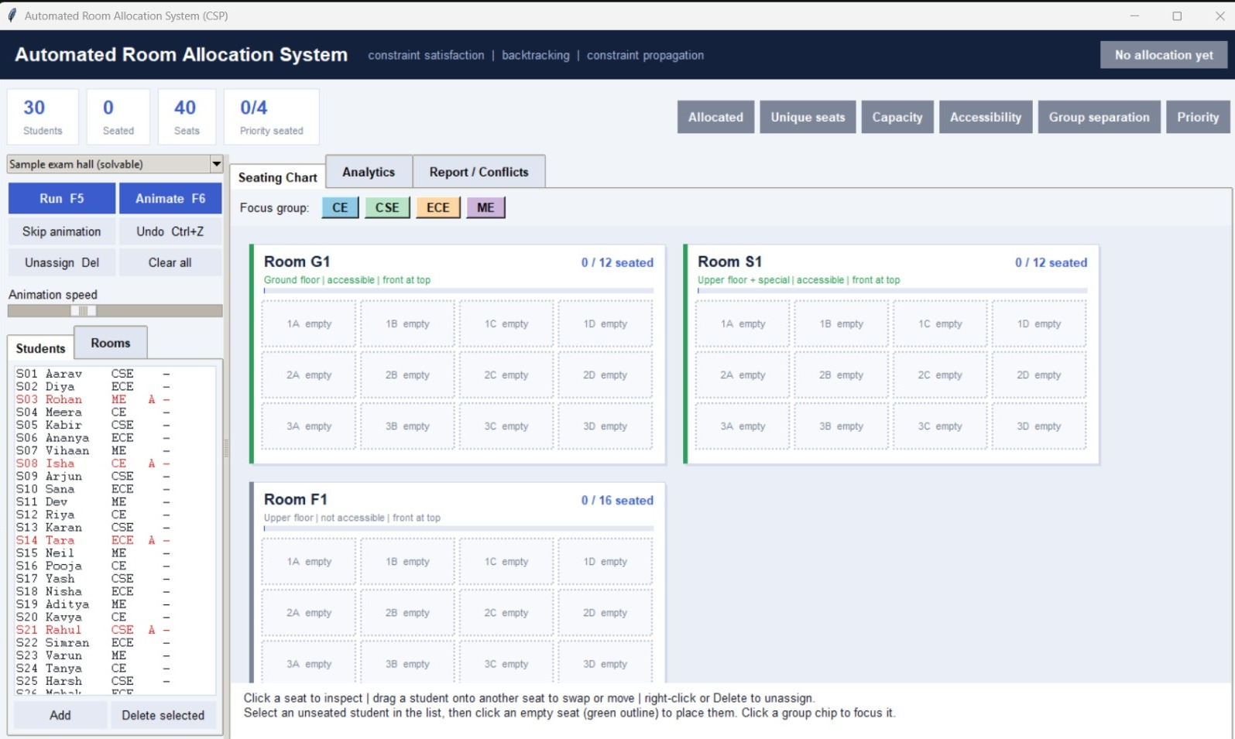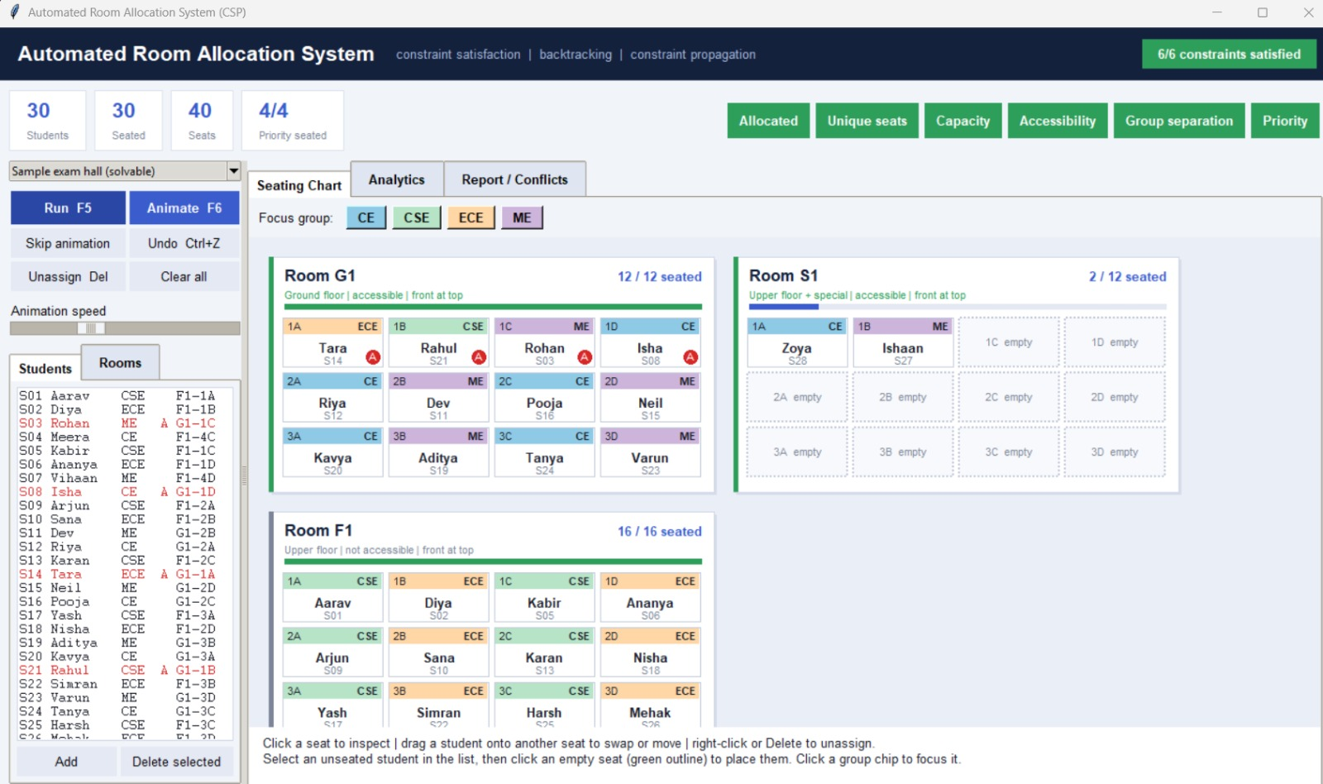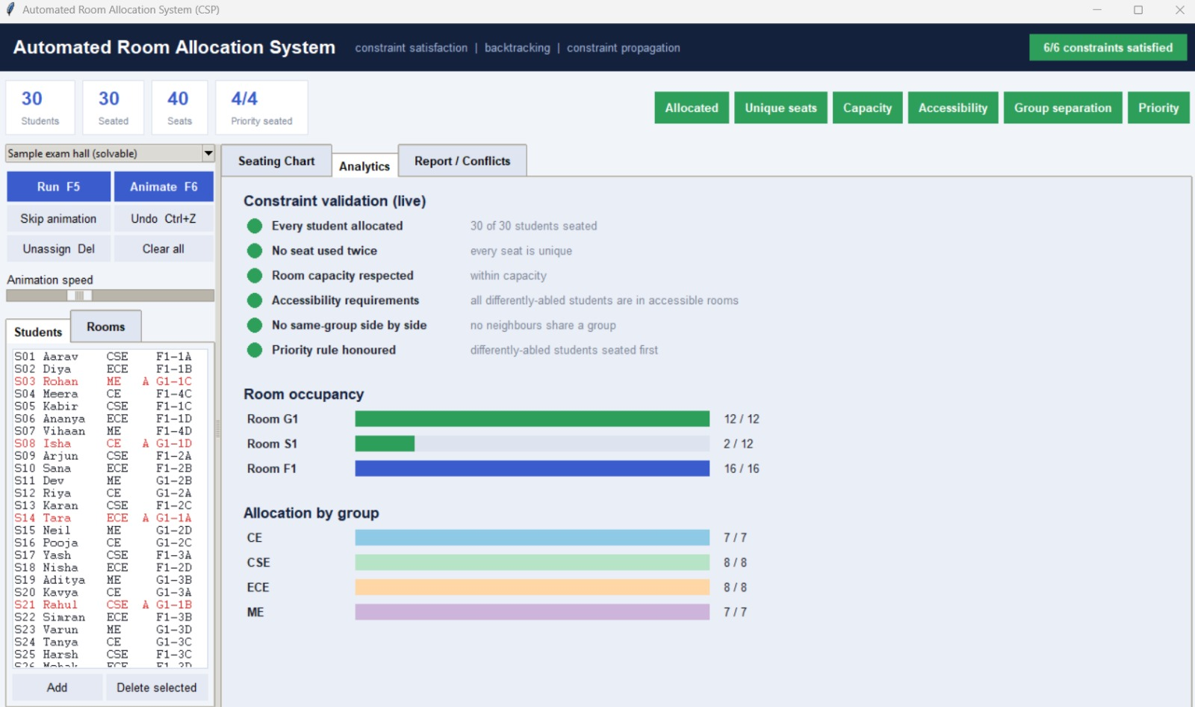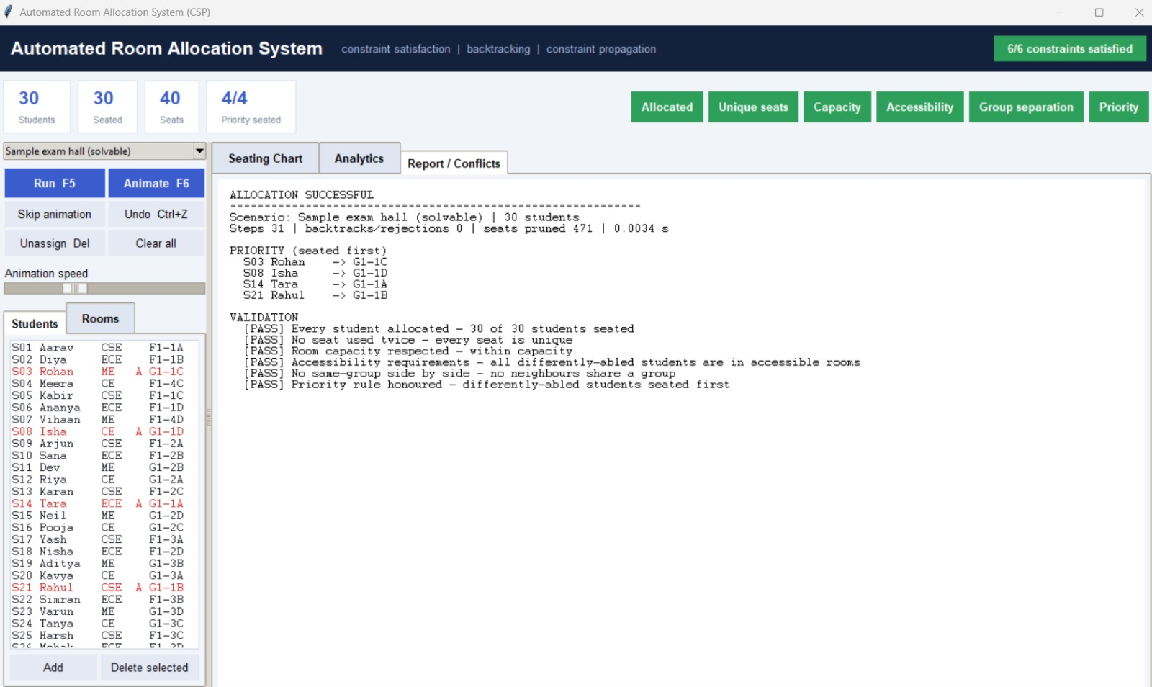
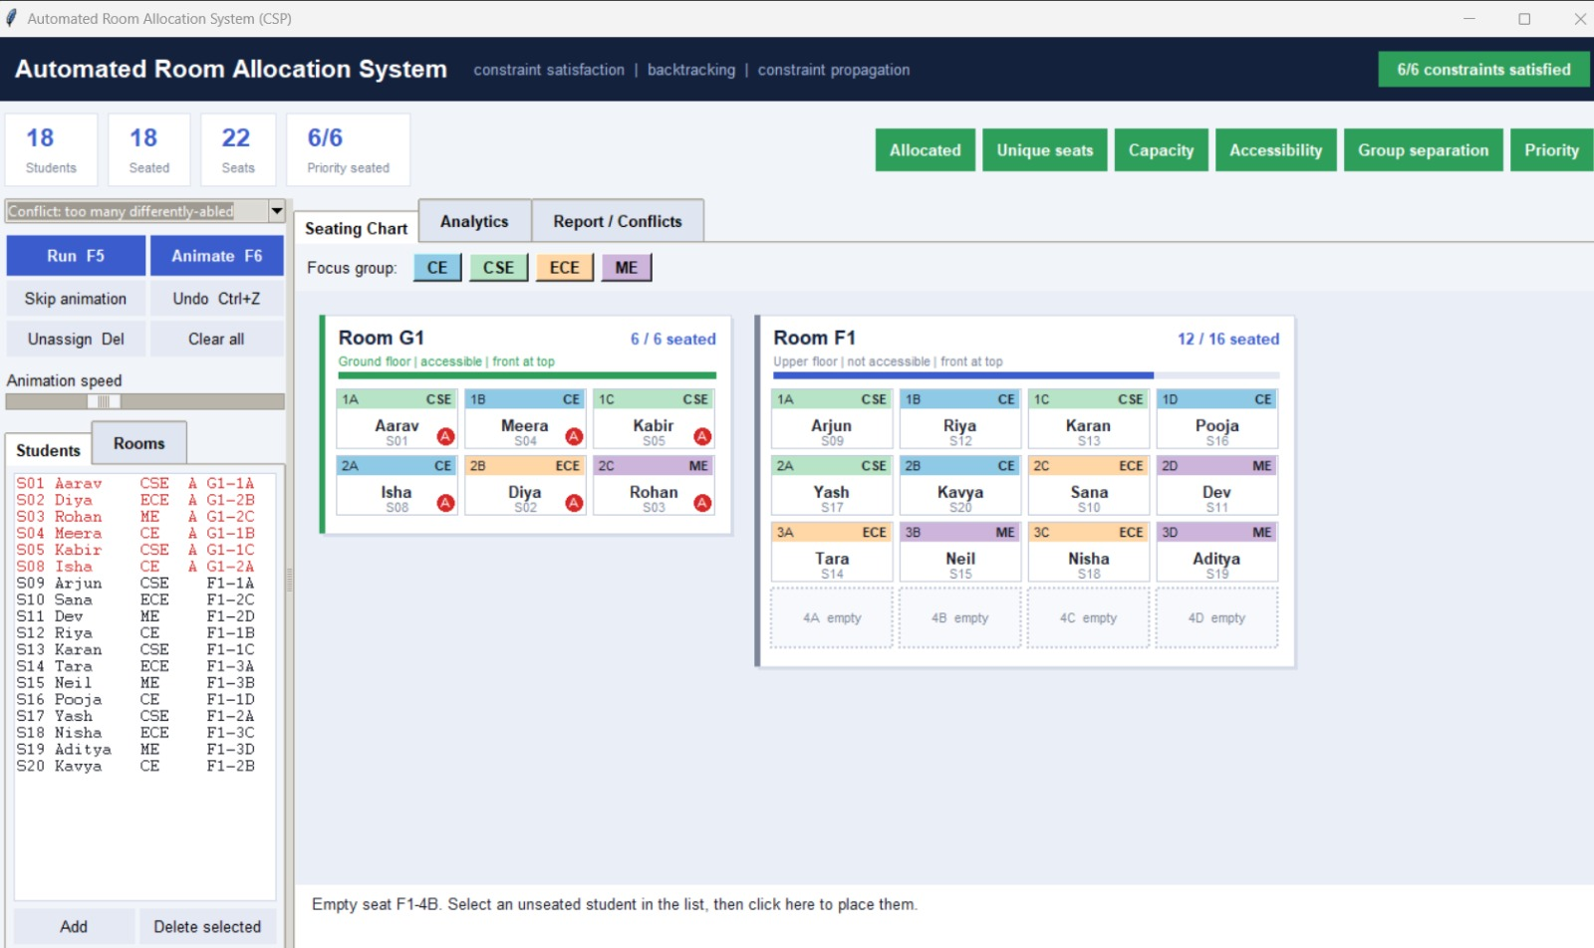
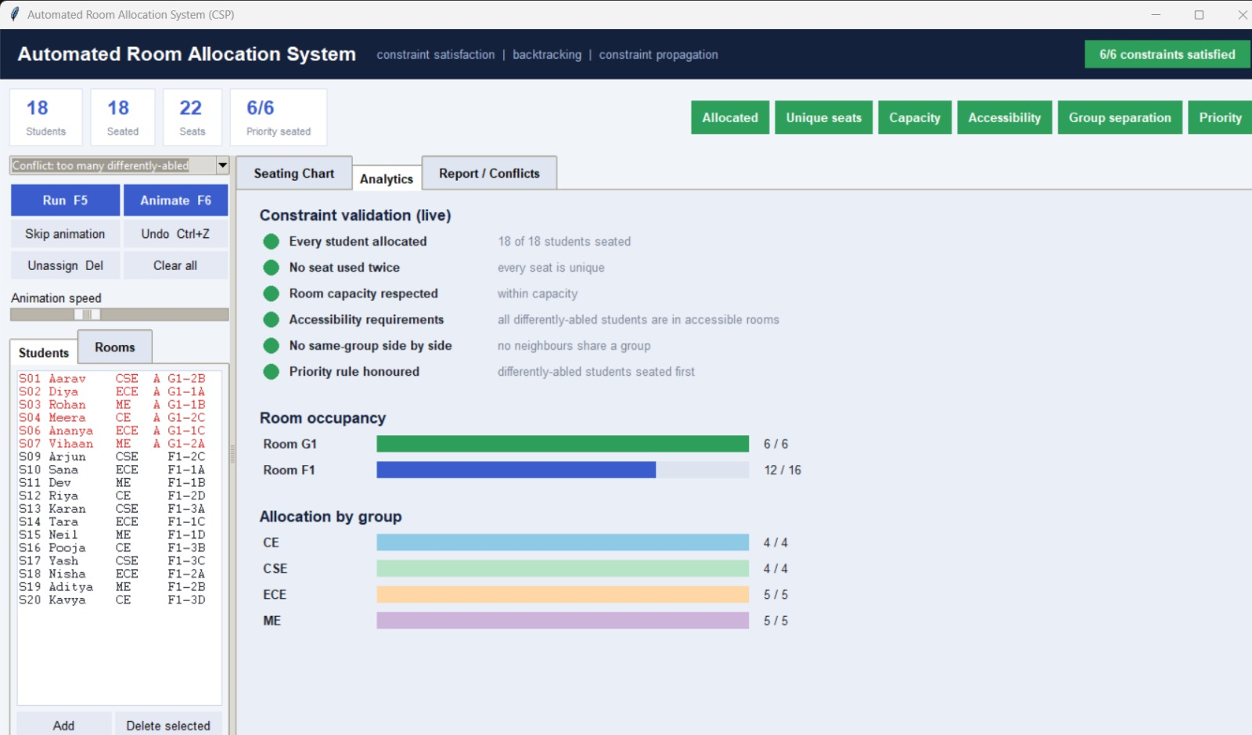

Algorithm Properties

The Automated Room Allocation System uses CSP-based Backtracking Search with MRV and Forward Checking. The following table describes its main algorithm properties.

Property | Explanation
Completeness | Yes, under finite domains and exhaustive search. If a valid seating arrangement exists, Backtracking can find it, provided no search limit or other cutoff stops the search.
Optimality | Not guaranteed. The algorithm finds a valid seating arrangement but does not guarantee the globally best arrangement.
Time Complexity | Worst-case exponential, approximately \(O(m^n)\), where \(n\) is the number of students and \(m\) is the maximum number of possible seats per student.
Space Complexity | Depends on the search depth, domain storage, and recursion. A simplified estimate is \(O(nm+n)\) for storing domains and the assignment, excluding temporary copies.

Implementation Details & Software Engineering

8.1Programming Language and Technologies Used
The Automated Room Allocation System is developed using Python 3. Python is used because of its simple syntax, flexibility, and support for implementing Artificial Intelligence algorithms.
The following technologies are used:
- Python 3: Main programming language.
- Tkinter: Used to develop the graphical user interface (GUI).
- CSP (Constraint Satisfaction Problem): Used to model the room allocation problem.
- Backtracking Search: Used to find valid student-seat assignments.
- Constraint Propagation: Used to reduce unsuitable seat options.
- MRV (Minimum Remaining Values): Used to select the student with the fewest available seat options.
- Python Data Structures: Lists, dictionaries, and sets are used to store student, room, seat, and allocation information.

8.2Implementation of Major Modules
The system is divided into different modules to make the application organized and easier to maintain.
Module | Implementation
Student Management | Stores student IDs, groups, and accessibility requirements.
Room Management | Maintains room details and available seats.
CSP Model | Defines students as variables and seats as domains.
Search Engine | Uses backtracking to find valid allocations.
Constraint Propagation | Removes occupied and unsuitable seats from domains.
Conflict Detection | Identifies capacity and constraint-related conflicts.
Validation | Checks whether the final seating arrangement is valid.
GUI | Displays controls, seating charts, analytics, and reports.

8.3Implementation of AI Algorithms
The system uses the following AI techniques:
- Backtracking Search: Assigns students to seats and returns to previous assignments when a conflict occurs.
- Minimum Remaining Values (MRV): Selects the unassigned student with the smallest number of available seats.
- Constraint Propagation: Updates the available seat options after every assignment.
- Forward Checking: Removes occupied seats and unsuitable adjacent seats from the domains of other students.
- Accessibility Priority: Gives priority to students who require accessible seating.

8.4 Graphical User Interface Implementation
The graphical user interface is developed using Python Tkinter. It allows users to operate the system without directly interacting with the source code.
The main GUI features include:
- Run: Starts automatic room allocation.
- Animate: Displays the allocation process step by step.
- Skip Animation: Completes the allocation without waiting for the animation.
- Undo: Reverses the previous action.
- Unassign: Removes a selected student's seat assignment.
- Clear All: Clears the current seating arrangement.
- Seating Chart: Displays the allocated seats.
- Analytics: Shows allocation-related information.
- Report / Conflicts: Displays allocation results and detected conflicts.

8.5 Error Handling and Validation
The system checks different conditions to prevent invalid seating arrangements. It detects insufficient room capacity, insufficient accessible seats, duplicate seat assignments, and same-group seating conflicts.
If a valid arrangement cannot be found, the system displays conflict information instead of presenting an invalid allocation as successful.

8.6 Software Engineering Practices
The project follows basic software engineering principles:
- Modularity: Different tasks are handled by separate functions and modules.
- Readability: Meaningful function names and organized code improve understanding.
- Reusability: Functions can be reused for different allocation operations.
- Maintainability: The modular structure makes future modifications easier.
- Testing: Different sample scenarios are used to check successful allocation and conflict detection.

8.7 Summary
The implementation combines Python programming, Tkinter GUI development, and Artificial Intelligence techniques to automate examination room and seat allocation. Backtracking, MRV, and constraint propagation help generate valid arrangements while the graphical interface makes the system easier to use.

9.Experimental Results

9.1 Benchmark Setup
The Automated Room Allocation System is tested using different sample scenarios to evaluate its performance, accuracy, and ability to handle seating constraints. The benchmark setup includes student details, room capacities, available seats, accessibility requirements, and group information.

1. Testing Environment
- Programming Language: Python 3
- GUI Framework: Tkinter
- Algorithm: Backtracking Search
- AI Technique: Constraint Satisfaction Problem (CSP)
- Optimization: Minimum Remaining Values (MRV) and Forward Checking

9.2 Interpretation of Results
The results of the Automated Room Allocation System demonstrate how effectively the application assigns students to examination seats while following predefined constraints. The system uses CSP, Backtracking Search, MRV, and Forward Checking to generate valid seating arrangements.

1. Successful Allocation
When sufficient seats and accessible facilities are available, the system successfully assigns students to seats. The seating chart displays the allocated students and their respective rooms and seat numbers.

2. Constraint Satisfaction
The system checks important seating conditions, including:
- Every student receives a seat.
- No seat is assigned to more than one student.
- Room capacity is not exceeded.
- Accessibility requirements are satisfied.
- Students belonging to the same group are not seated side by side.

3. Conflict Detection
When the available resources are insufficient or constraints cannot be satisfied, the system identifies the problem and displays a conflict report. This helps users understand why a valid arrangement could not be generated.

4. Algorithm Performance
MRV reduces unnecessary search by selecting students with fewer available seats first. Forward Checking removes unsuitable seat options, while Backtracking allows the system to reconsider earlier assignments when conflicts occur.

5. Overall Interpretation
The project demonstrates that AI-based search techniques can simplify the examination room allocation process. It reduces manual effort, improves seating accuracy, supports accessibility requirements, and provides a clear visual representation of the final allocation.

9.3 Search Process and Explainability
The Automated Room Allocation System uses Backtracking Search and Constraint Propagation to find a valid seating arrangement. The system selects unassigned students using the Minimum Remaining Values (MRV) technique, which prioritizes students with fewer available seat options. Accessibility requirements are considered when selecting students and candidate seats.
During the allocation process, the system checks constraints such as room capacity, seat availability, accessibility, and group separation. Forward Checking updates the remaining seat options after each assignment. If a conflict occurs, the system uses backtracking to return to an earlier assignment and try another available seat. The application also provides conflict explanations and allocation reports to help users understand the results.

9.4 Dynamic Allocation and Constraint Scenarios
The system supports different seating scenarios based on student details, room capacity, and accessibility requirements. It checks whether enough seats are available before starting the allocation process. If accessibility requirements cannot be satisfied or students have no valid seat options, the system displays an appropriate conflict message.
When a student is assigned a seat, Forward Checking updates the available options for the remaining students. It removes occupied seats and adjacent seats for students belonging to the same group. If an assignment creates a conflict, Backtracking Search attempts an alternative arrangement. The application also provides Undo, Unassign, and Clear All options to manage seating assignments.

9.5 Challenges Encountered & Solutions
Managing Student and Room Information: Handling multiple students, rooms, and seats was challenging. This was addressed using Python lists, dictionaries, and sets to organize the information. Defining Seating Constraints: Different seating requirements had to be considered. The system uses constraints such as room capacity, unique seat allocation, accessibility, and group separation.
Choosing a Suitable Search Algorithm: Finding valid seat arrangements requires exploring different possibilities. Backtracking Search was implemented to find suitable assignments while returning to previous choices when conflicts occur. Reducing Search Complexity: Checking every possible arrangement can be time-consuming. The MRV technique helps select the student with the fewest available seat options first.
Handling Allocation Conflicts: Some seating scenarios may not have a valid solution. Forward Checking and conflict detection help identify invalid options and reduce unnecessary searches and Prioritizing Accessibility Students requiring accessible seating need special consideration. The system prioritizes accessibility students and prefers accessible seats during allocation.

10.Limitations & Future Scope

10.1 Current System Limitations
Although the Automated Room Allocation System provides an efficient way to allocate students to examination seats, it has certain limitations:
1. No External Database: The system currently uses Python data structures such as lists, dictionaries, and sets instead of an external database.
2. Manual Data Entry: Student and room details need to be provided within the application. Automatic data import is not implemented.
3. Limited Accessibility Information: The system considers predefined accessibility requirements and available accessible seats.
4. Fixed Constraints: The allocation process follows predefined rules, such as room capacity, seat uniqueness, accessibility, and group separation.
5. No Online Access: The application is a desktop-based system developed using Python Tkinter and does not provide web-based access.
6. Limited User Management: User authentication and separate administrator accounts are not currently implemented.
7. No Automatic Data Synchronization: Changes in student or room information are not synchronized with any external system.
8. Limited Reporting Options: The system displays seating information, analytics, and conflict reports, but advanced report export and printing features are not included.

10.2 Future Scope & Enhancements
The Automated Room Allocation System can be further improved by adding advanced features to make it more efficient, flexible, and suitable for large-scale examination management.
    - Database Integration: Connect the application with a database such as MySQL or SQLite to store student, room, and seating information permanently.
    - Automatic Data Import: Add options to import student details from Excel or CSV files instead of entering information manually.
    - User Authentication: Introduce secure login facilities for administrators and examination staff.
    - Advanced Room Management: Allow administrators to add, update, and remove rooms and seating arrangements dynamically.
    - Improved Allocation Algorithm: Enhance the CSP and Backtracking approach to handle larger numbers of students and rooms efficiently.
    - Customizable Constraints: Allow administrators to define additional seating rules according to examination requirements.
    - Printable Reports: Add options to export seating charts, student allocation lists, and conflict reports in PDF or Excel formats.
    - Web and Mobile Integration: Develop a web-based or mobile-friendly version so authorized users can access allocation information from different devices.
    - Notification System: Introduce automatic notifications to inform students about their examination room and seat numbers.
    - . Performance Testing: Test the system with larger datasets and different seating scenarios to evaluate its speed, accuracy, and reliability.
    - Overall: These enhancements can transform the current desktop-based application into a more advanced, scalable, and user-friendly examination room management system.

11 . Conclusion

The Automated Room Allocation System successfully demonstrates how Artificial Intelligence techniques can be used to simplify and improve the process of examination room and seat allocation. The system uses a Constraint Satisfaction Problem (CSP), Backtracking Search, Minimum Remaining Values (MRV), and Forward Checking to assign students to suitable seats while satisfying important constraints such as room capacity, seat availability, accessibility requirements, and group separation.

The Python Tkinter-based graphical user interface makes the system easy to operate by providing automatic allocation, seating charts, analytics, conflict reports, and options such as undo and unassign. It also identifies situations where a valid allocation is not possible and displays appropriate conflict messages.

Overall, this project reduces manual effort, improves allocation accuracy, and provides an organized approach to examination seating management. In the future, the system can be enhanced with database integration, automatic student data import, user authentication, and printable reports.

12.References & Bibliography

Russell, S. J., & Norvig, P. (2020). Artificial Intelligence: A Modern Approach (4th ed.). Pearson. Chapters on intelligent agents, constraint satisfaction problems, and problem-solving techniques.

Mackworth, A. K. (1977). Consistency in Networks of Relations. Artificial Intelligence, 8(1), 99–118.

Python Software Foundation. Python 3 Documentation. Available at: https://docs.python.org/3/

Python Software Foundation. Tkinter — Python Interface to Tcl/Tk. Available at: https://docs.python.org/3/library/tkinter.html

GeeksforGeeks. Backtracking Algorithm and Constraint Satisfaction Problems. Available at: https://www.geeksforgeeks.org/

TutorialsPoint. Python Programming Tutorial. Available at: https://www.tutorialspoint.com/python/

W3Schools. Python Programming Concepts. Available at: https://www.w3schools.com/python/

FLOWCHART



